GPS/glonass Dielectric Antenna Specification
( Model: BY-GPS-Glonass-254-SMD )
Serial Number
GPS/Glonass Dielectric Antenna
Jiaxing Beyondoor Technology Co., Ltd

( I ) Product Overview
( i ) Dielectric Antenna
Item | Content
Nominal frequency MHz | 1575/1602
Return Loss at Center Frequency dB max | -20.0
Gain (Zenith 90°) dBi type | 2.0
Polarization Model | RHCP
Impedance | 50 Ω
Axial Ratio dB max | 3.0
Frequency Temperature Coefficient | 20ppm/deg.℃ max
* Center frequency :-10dB bandwidth center frequency. depend on the ground plane of customers.

（ii）Mechanical
Weight （gram）＜10
Size （mm）：18×18×4
（iii）Environmental
Working Temp：-40℃~+85℃
Storage Temp：-45℃~+90℃
Vibration：Sine sweep 1g(0-p)10~50~10Hz each axis
Humidity：Humidity95%~100%RH

( II ) Mechanical
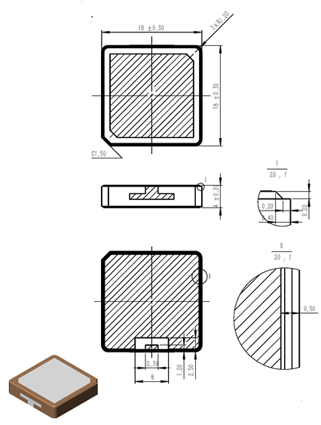
Unit:mm
（III）Characteristic curve
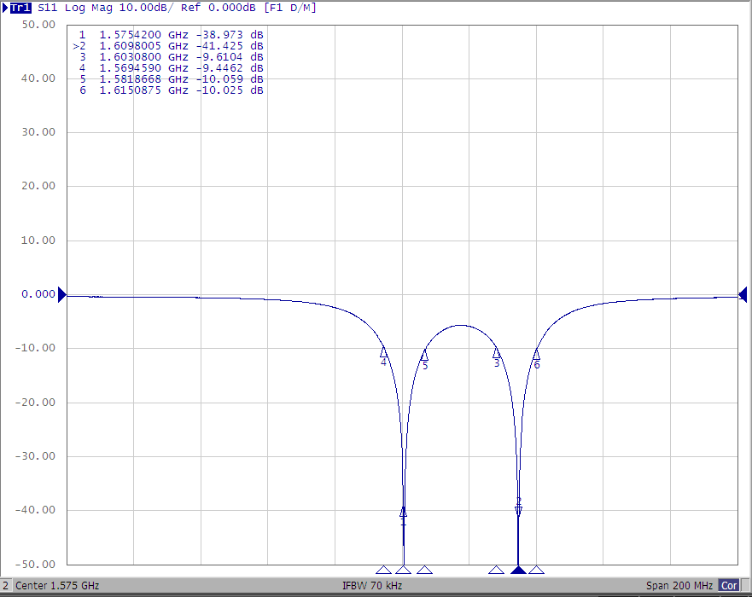

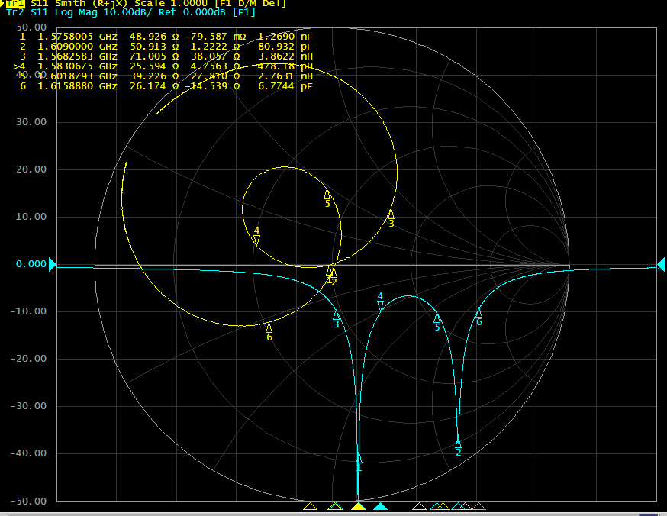
（IV）Reflow profile
